**Chirag Kumar,MID: M1092047**

**MILESTONE 5**

* Firstly create Spring-boot rest Api :

Running Screenshot

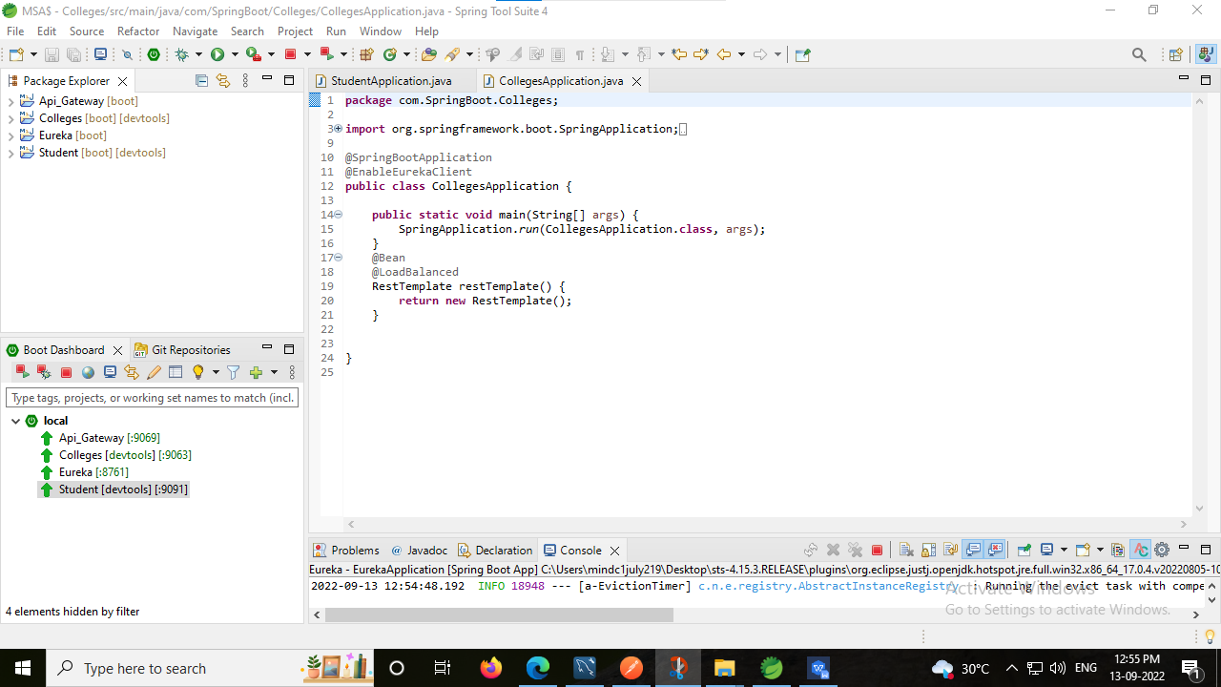

* Runing Ureka Server:

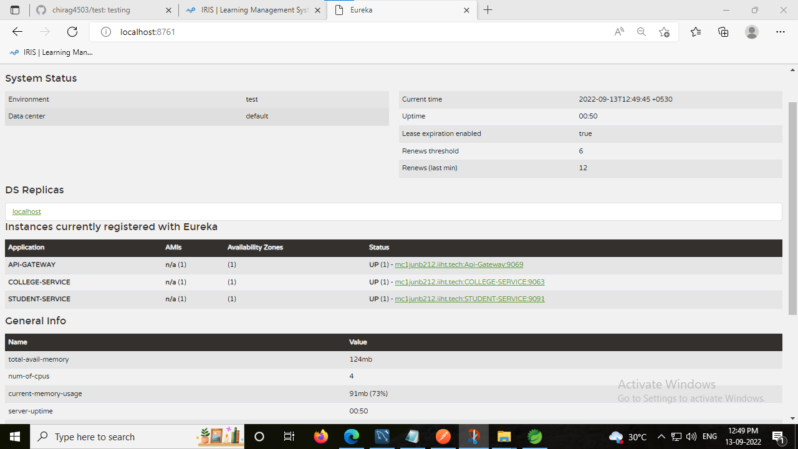

1. Create Colleges . Create at least 3-4 Colleges:

Post collage

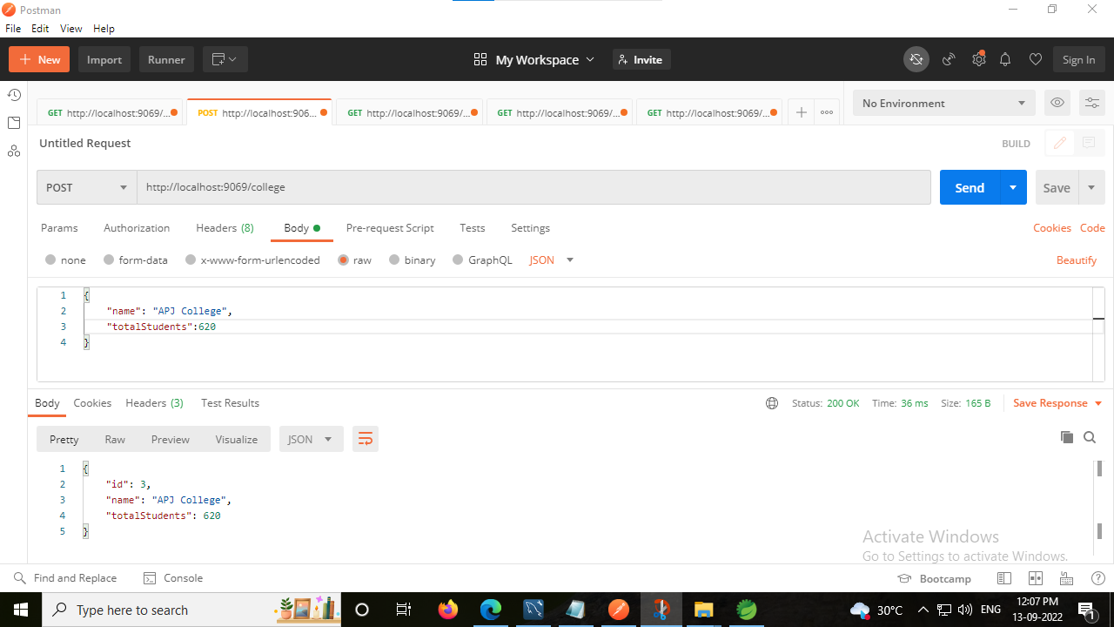

Get collage:

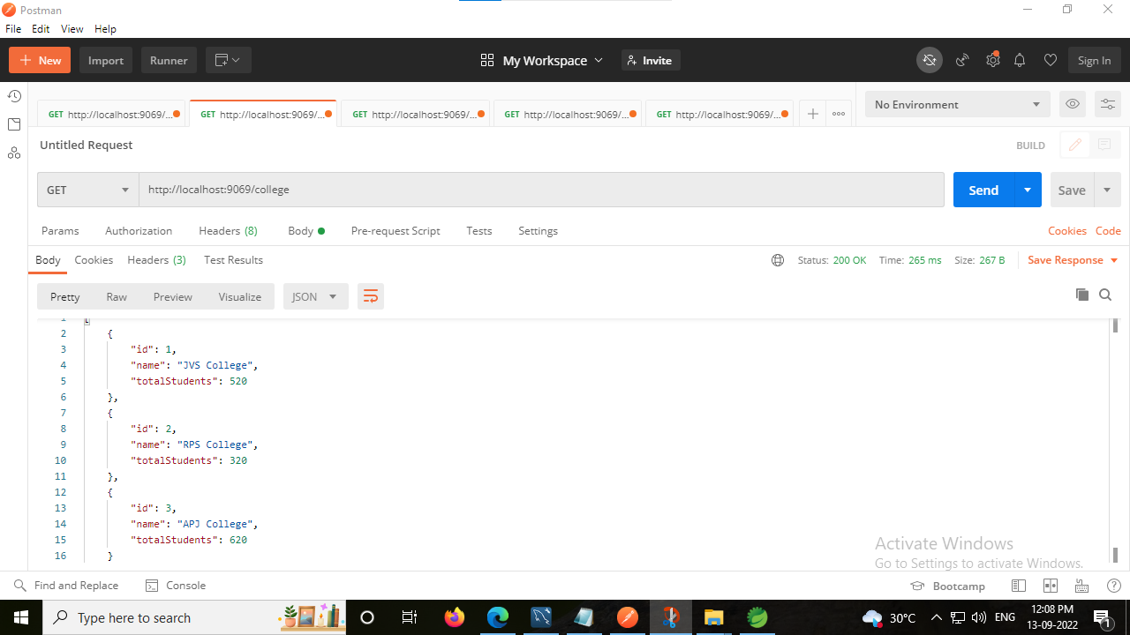

2. Create Students. Create at least 10-12 students.

Post Student

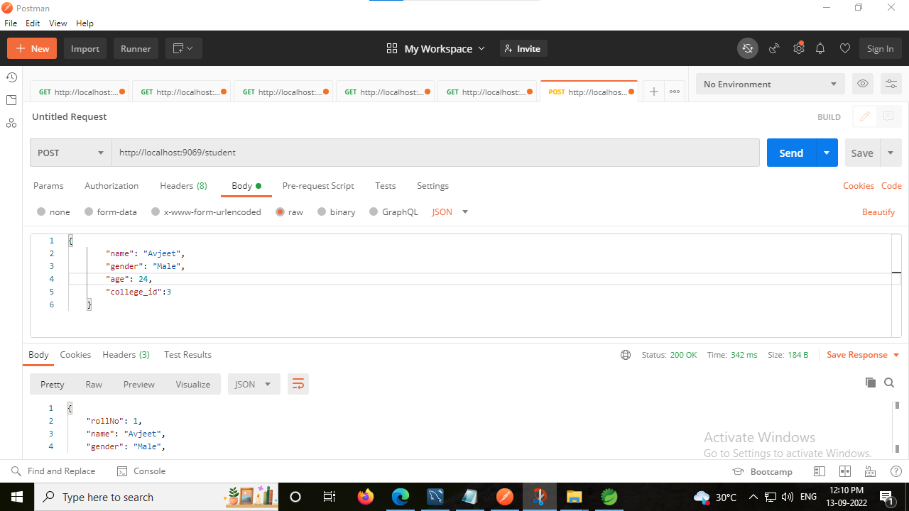

get Student

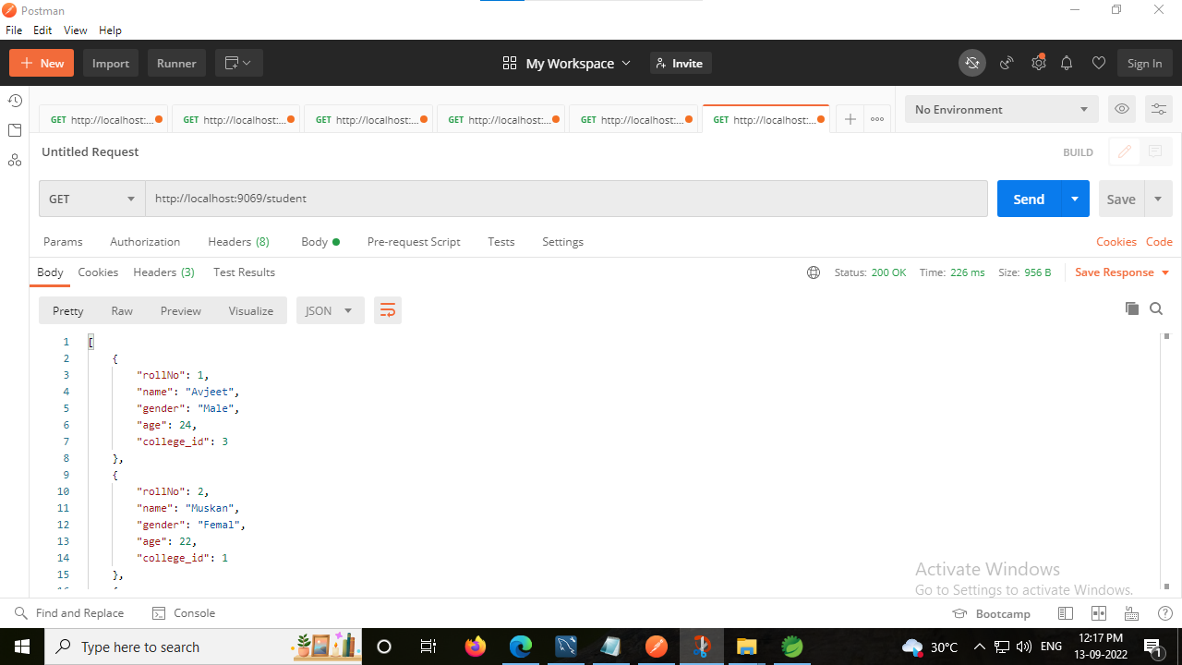

1. Assign Students to College.

Before Assign in collage

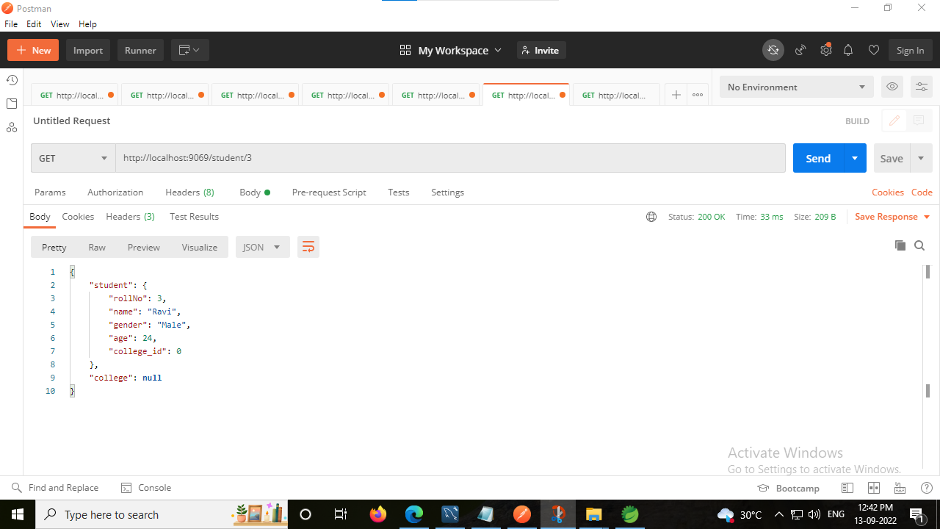

Assigning in collage

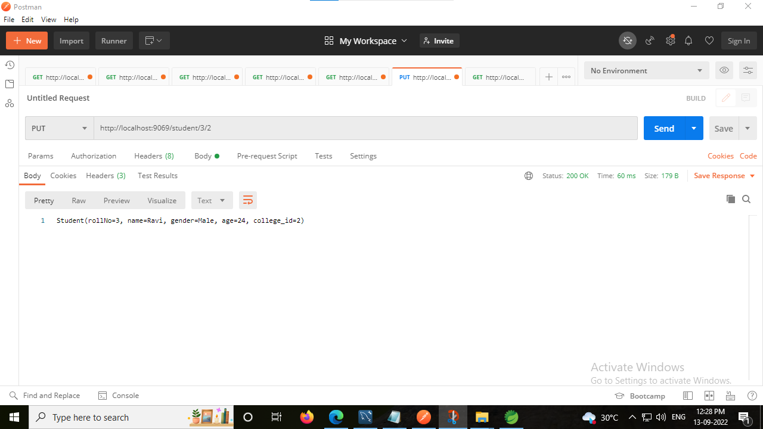

After Assigned in collage

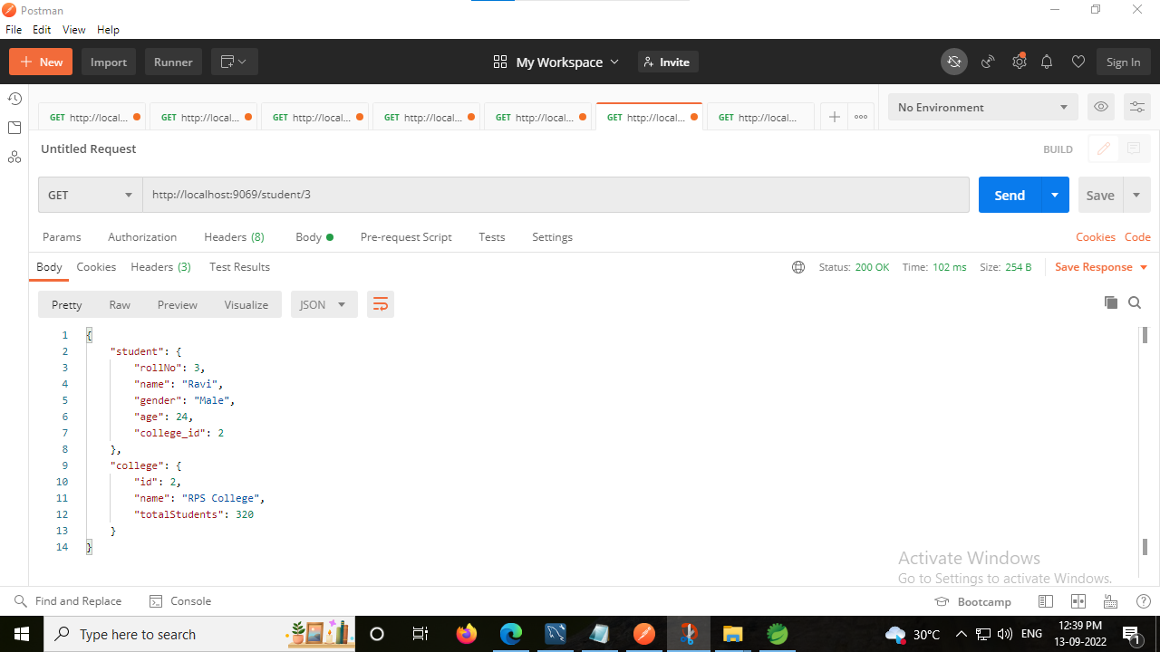

Reference Database collage:

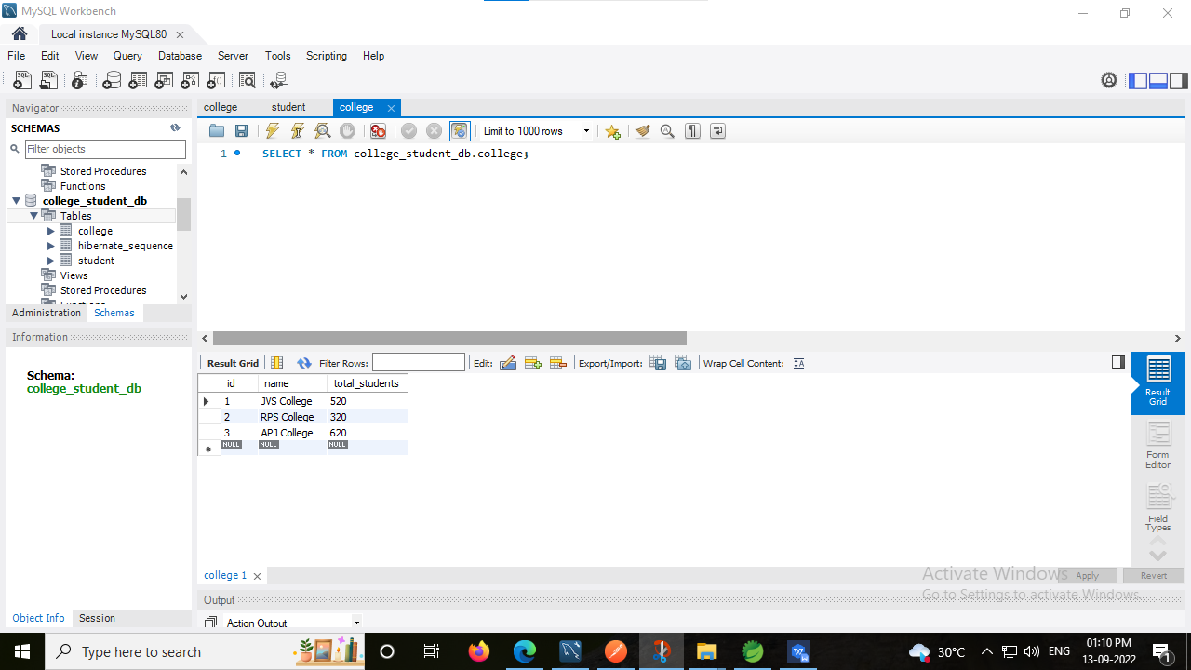

Reference Database Student:

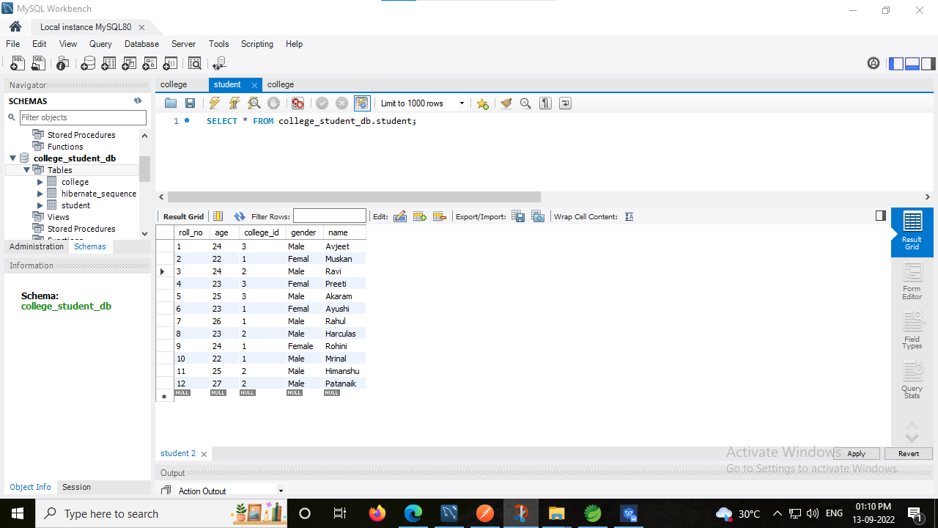

1. Display all Colleges and the corresponding Students under the College based on their name in ascending order.

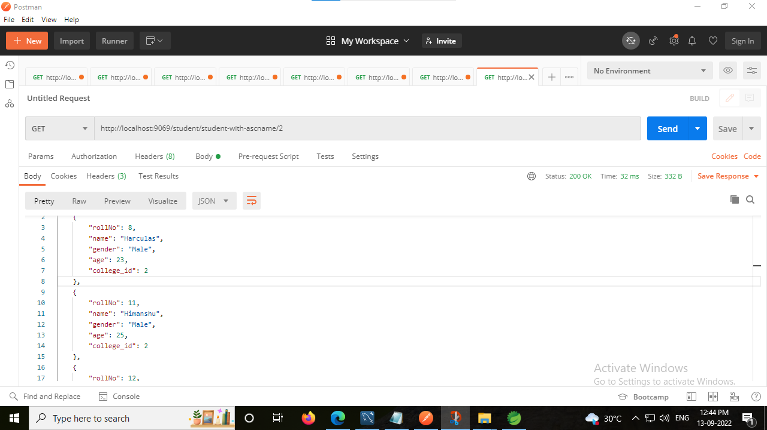

5.Show all Students for a particular College based on their age in descending order.

